World’s largest rectangular EPB Box jacking machine drives forward.
Zhengzhou a city of more than 10 million people city suffers from heavy traffic particularly on its main North-South arterial highway. ZURPB (Zhengzhou Urban and Rural Planning Bureau) decided to construct 3quadruple-tunnels (see graphic)to underpass this busy road. According to the plan, each completed quadruple-tunnelconsist of twin 8×4.5 m tunnels for vehiclesand twin 6×2.8m for non-motorized vehicle. Work scope of lot 2 includes Weisi Road tunnel and Shenzhuangbeilu–Shangding Road tunnel. Weisi Road tunnel consists of 100m bored tunnel section and 150m cut and cover section. Shenzhuangbeilu – Shangding Road tunnelconsists of 190m bored tunnel section and 605m cut and cover section.

Lot 1 which includes HongzhuangRoad tunnel is currently underway and consists of 105m bored tunnel section as well as a545m cut and cover section. The over burden is 8 m with the tunnel excavation dimensions of 10.1m wide and 7.45 m high. CREG have manufactured the world Largest EPB Box jacking machine to complete this project.

The Box jacking machine has 6 cutterheads, each cutterhead with 6 motor drives with power of 180kw. Torque for each cutterhead is 1,444kN.m. So far the machine has completed 40 m of box jacking with average advance rates of 3 m per day and maximumadvance rate 4.5 m per day.

Project manager Yang Hongjunis quoted as saying “the world largest pipe jacking machine shows its excellent performance and will make breakthrough at the end of this month.”
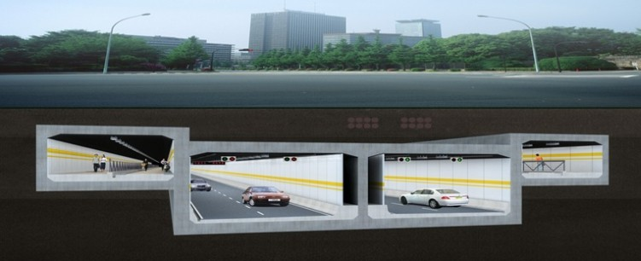
Picture 1.Overview of quadruple-tunnel section

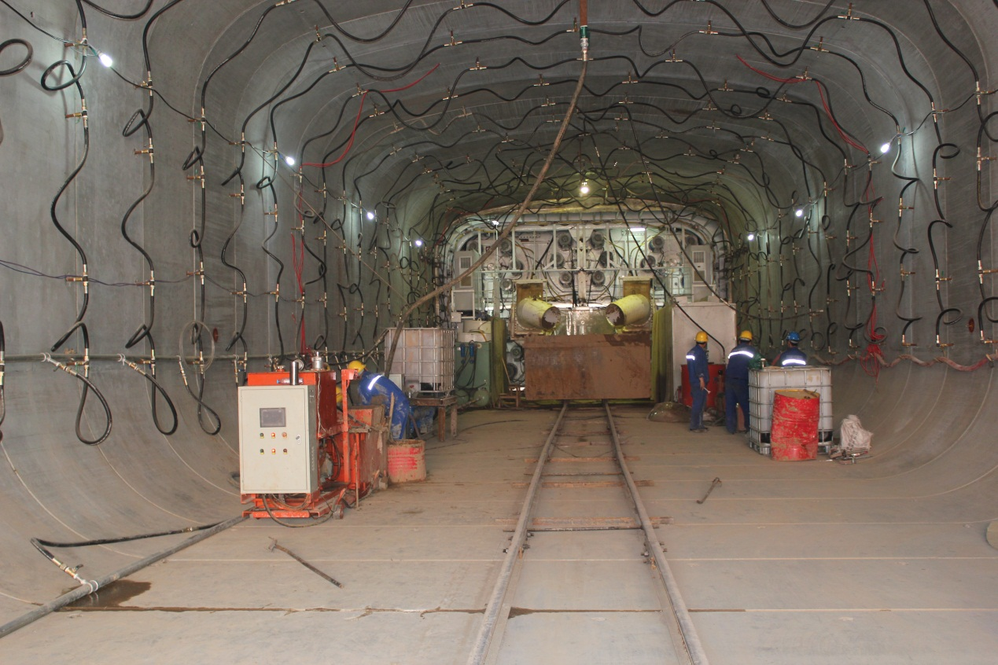
Picture 2. View of box jacking tunnel under construction.
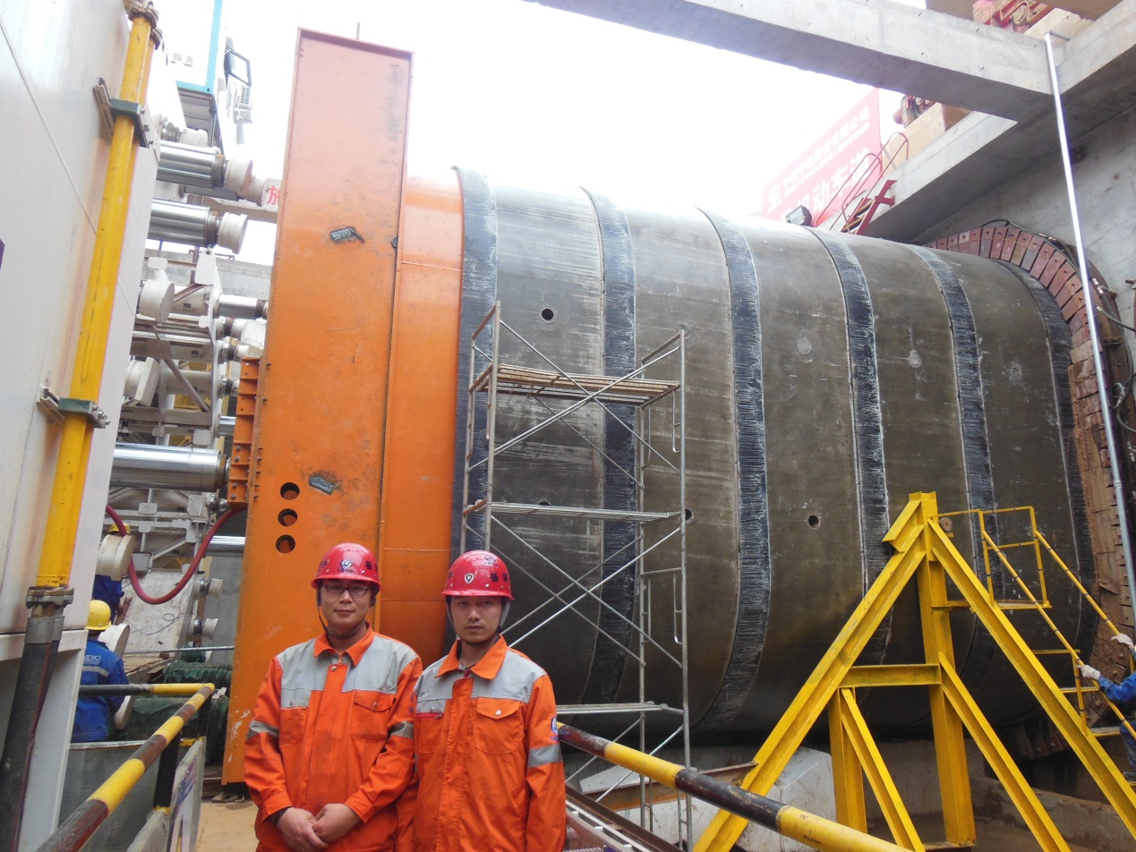
Picture 3.CREG staff alongside the jacking station.
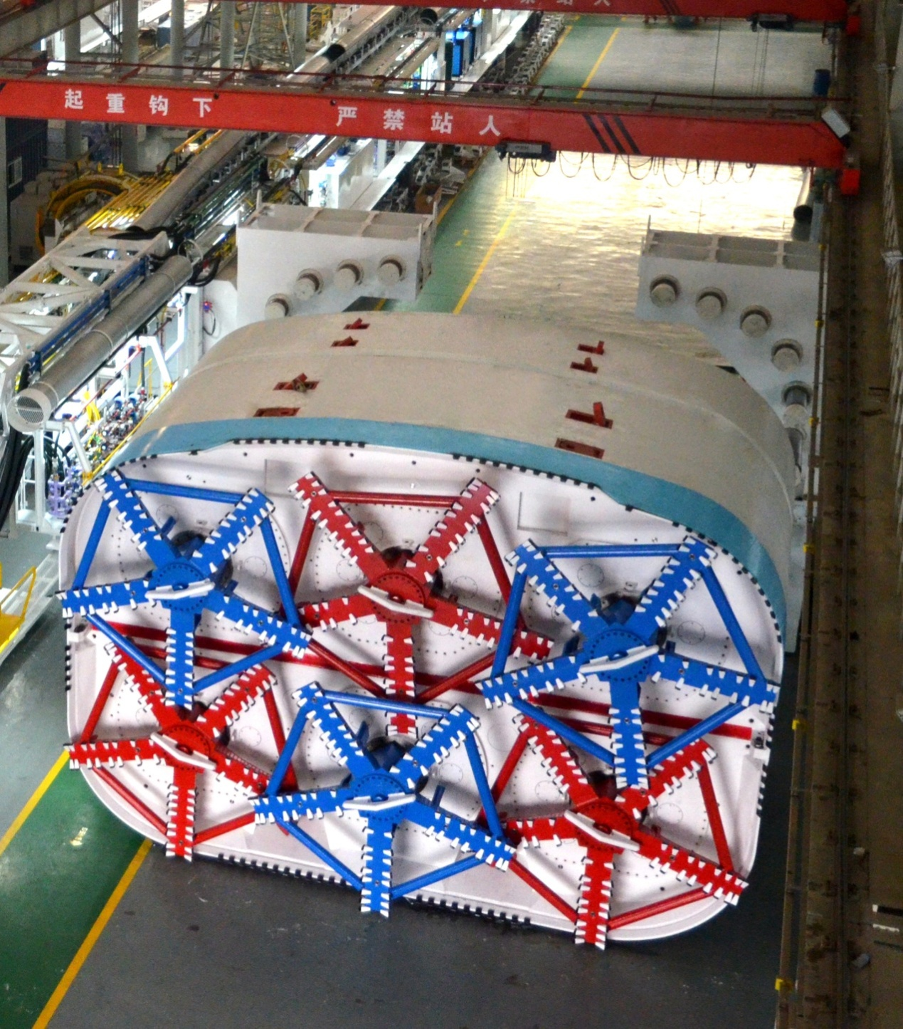
Picture 4.Box Jacking EPB after Factory Acceptance Test (FAT).

CREG can supply TBMs internationally and providing an experienced and international source for these high quality machines. They are able to supply slurry tunnelling machines, - CREG recently received an order for Slurry machines for the Wuhan Metro - and Hard Rock tunnelling machines, based on the WIRTH technology which has recently been acquired a well as EPB machines for which over 140 orders have been received in the last 4 years including machines currently working on the Klang Valley MRT in Malaysia. Along with CTE Ltd, are also able to supply full after sale support, including on-site field service using both Chinese and ex-pat skilled technicians.

All enquiries should be addressed to:

sunheng@crectbm.com

China Railway Engineering Equipment GroupCo.Ltd. (CREG)

No.99,6th avenue, Zhengzhou, China
Tel:+86 (0) 371 60608991
Fax :+86 (0) 371 60608819
website: www.crectbm.com

Or

enquiries@cte-limited.com

CTE Ltd.
Unit 908, Block B, PhileoDamansara II
No.15, Jalan 16/11 off JalanDamansara
Section 16, 46350 Petaling Jaya
Selangor, Malaysia
Tel : +603 7954 0314
Fax : +603 7931 1977

